
OMA Report on Automotive Opportunity
Draft – dd Mmm 2016
Open Mobile Alliance
Use of this document is subject to all of the terms and conditions of the Use Agreement located at http://www.openmobilealliance.org/UseAgreement.html.
Unless this document is clearly designated as an approved specification, this document is a work in process, is not an approved Open Mobile Alliance™ specification, and is subject to revision or removal without notice.
You may use this document or any part of the document for internal or educational purposes only, provided you do not modify, edit or take out of context the information in this document in any manner. Information contained in this document may be used, at your sole risk, for any purposes. You may not use this document in any other manner without the prior written permission of the Open Mobile Alliance. The Open Mobile Alliance authorizes you to copy this document, provided that you retain all copyright and other proprietary notices contained in the original materials on any copies of the materials and that you comply strictly with these terms. This copyright permission does not constitute an endorsement of the products or services. The Open Mobile Alliance assumes no responsibility for errors or omissions in this document.
Each Open Mobile Alliance member has agreed to use reasonable endeavors to inform the Open Mobile Alliance in a timely manner of Essential IPR as it becomes aware that the Essential IPR is related to the prepared or published specification. However, the members do not have an obligation to conduct IPR searches. The declared Essential IPR is publicly available to members and non-members of the Open Mobile Alliance and may be found on the “OMA IPR Declarations” list at http://www.openmobilealliance.org/ipr.html. The Open Mobile Alliance has not conducted an independent IPR review of this document and the information contained herein, and makes no representations or warranties regarding third party IPR, including without limitation patents, copyrights or trade secret rights. This document may contain inventions for which you must obtain licenses from third parties before making, using or selling the inventions. Defined terms above are set forth in the schedule to the Open Mobile Alliance Application Form.
NO REPRESENTATIONS OR WARRANTIES (WHETHER EXPRESS OR IMPLIED) ARE MADE BY THE OPEN MOBILE ALLIANCE OR ANY OPEN MOBILE ALLIANCE MEMBER OR ITS AFFILIATES REGARDING ANY OF THE IPR’S REPRESENTED ON THE “OMA IPR DECLARATIONS” LIST, INCLUDING, BUT NOT LIMITED TO THE ACCURACY, COMPLETENESS, VALIDITY OR RELEVANCE OF THE INFORMATION OR WHETHER OR NOT SUCH RIGHTS ARE ESSENTIAL OR NON-ESSENTIAL.
THE OPEN MOBILE ALLIANCE IS NOT LIABLE FOR AND HEREBY DISCLAIMS ANY DIRECT, INDIRECT, PUNITIVE, SPECIAL, INCIDENTAL, CONSEQUENTIAL, OR EXEMPLARY DAMAGES ARISING OUT OF OR IN CONNECTION WITH THE USE OF DOCUMENTS AND THE INFORMATION CONTAINED IN THE DOCUMENTS.
© 2016 Open Mobile Alliance Ltd. All Rights Reserved.
Used with the permission of the Open Mobile Alliance Ltd. under the terms set forth above.
Contents
1. Scope 5
1.1 OMAuto Goal 5
1.2 Deliverables 5
Medium = technical report with a set of agreed recommendations to drive future standardization work (25-50 pages) 5
2. References 6
3. Terminology and Conventions 7
3.1 Conventions 7
3.2 Definitions 7
3.3 Abbreviations 7
4. Introduction 8
4.1 Observed Problem 8
4.2 Hot Projects in Open Automotive 8
5. Automotive Opportunity 9
5.1 DM 9
5.2 Device APIs in Automotive 9
5.2.1 OMA Enablers: Example of possible work for Automotive 9
GotAPIs 10
10
5.2.2 Example of RVI and OMA Devices APIs 10
Appendix A. Change History (Informative) 12
Appendix B. <Additional Information> 13
B.1 App Headers 13
B.1.1 More Headers 13

Figures
Figure 1: Example Figure 8

Tables
Table 1: Example Table 8

Scope

OMAuto Goal
  - Establish a venue for discussion between telecom and automotive at a technical and industry level to establish any network, any automobile connectivity.
  - Adapt select current specifications to optimize for the needs of the Automotive market.
  - Create a path for Auto industry to interface with the rest of IoT via standardized enablers.
  - Bridge existing standards with standardization efforts in the Automotive sector.
Enable a path for automakers and operators to encourage communications interoperability across automotive and wireless industries.

Deliverables

Medium = technical report with a set of agreed recommendations to drive future standardization work (25-50 pages)
  - Get agreement across participating parties as to what work needs to be done and where (which SDO) it needs to be done.
  - Examine landscape across mobile and automotive environment
  - Identify areas of overlap across industry work groups (RVI, W3C, GSMA, 3GPP, OMA, Smart Device Link, Apple CarPlay and Android Auto, OCF, etc…)
  - Produce use cases/examples including interaction between IoT and automobile
  - Roadmap and proposed timeline of future work needed, for example
    - Security-related issues
    - Enabler creation or reuse to facilitate development of enhanced services
    - Work with additional verticals (environmental, safety, healthcare)
  - Deliverables publication to be public and available online
  - Reference code-based projects already underway
  - Clarify what should be standardized, open source vs. proprietary to encourage interoperability
  - Other TBD

References
The policy for reference lists is:
1. OMA documents listed should have at least one approved version – draft-only docs should not be referenced. Exception exists for documents that will be approved with or after the referenced doc is approved (may be part of same enabler package). In short – approved docs should not reference unapproved docs.
2. When a reference is made to an OMA specification, then Open Mobile Alliance with the TM symbol (™) should be used in the description.
3. The name + version (no date) for OMA specifications are generally sufficient – dates should be used only if there is a specific reason to limit the usage.
4. For references to WAP Forum docs, dates should not be included as DID's for the old WAP Forum specifications are enough and the reference description should refer to WAP Forum™.
5. References to other affiliate docs should similarly provide sufficient information to uniquely determine the needed document and should provide the appropriate source information.
6. The URL for OMA material (new OMA and affiliate) should always be http://www.openmobilealliance.org (an exception is OMNA that is reached through http://www.openmobilealliance.org/tech/omna)
Models to use
[REFLABEL] <General Model> “Ref Title”, Ref information (source, date, id),
URL:http//<ref-source>/
[OMADOC] <OMA Model> “OMA Document Title”,{ Version x.y,} Open Mobile Alliance™, OMA-<docname>{-<version>}, URL:http//www.openmobilealliance.org/
If there are no entries in the table – enter ‘none’ to be clear.
Check the version of the Dictionary you are using and update the reference below. Delete the [OMADICT] entry if the dictionary is not used. In general, use the latest available version unless seeking alignment with an existing set of specifications.
DELETE THIS COMMENT
[OMADICT] | “Dictionary for OMA Specifications”, Version x.y, Open Mobile Alliance™,  OMA-ORG-Dictionary-Vx_y, URL:http://www.openmobilealliance.org/
<< Add/Remove reference rows to this table as needed - DELETE This Row >>

Terminology and Conventions

Conventions
This is an informative document, which is not intended to provide testable requirements to implementations.
<< If needed, describe or declare any additional conventions used. DELETE THIS COMMENT >>

Definitions
<< Add definitions in new rows of the following table as needed. The following examples show how dictionary references should be made as well as locally defined terms. This table should be maintained in sorted alphabetic order based on the labels of the terms.
Examples:
Entity Use definition #1 from [OMADICT]
Interactive Service Use definition from [OMADICT]
Local Term The definition description would be presented directly
DELETE THIS COMMENT>>
<< Add/Remove definition rows to this table as needed - DELETE This Row >>

3.3 Abbreviations
<< Add abbreviations as needed to the following table. No special notation should be made regarding terms copied from the Dictionary. This table should be maintained in alphabetic order.
DELETE THIS COMMENT >>
OMA | Open Mobile Alliance
<< Add/Remove abbreviation rows to this table as needed - DELETE This Row>>

Introduction

Observed Problem
- Problem statement 1
  - There are a series of initiatives in the automotive industry that will touch the mobile environment
  - There is work going on in the mobile/IoT industry that will need to interoperate with automobiles
    - It is important for all not to waste resources by “reinventing the wheel”
    - Use good protocols that already exist and are deployed
  - There are a number of one-to-one company level programs underway, there is NOT a conversation happening at the industry-to-industry level to insure standards-based interoperability and reduce fragmentation of protocols across automotive interacting with IoT and mobile services
  - The overall needs of the automotive industry are not being translated into mobile/IoT industry developments – harmonization of requirements and solutions between the mobile and the automobile environments. What are the problems the automotive industry are trying to solve?
- Problem statement 2
  - The auto industry wants to ensure openness and mobile device interoperability in relation to the automotive telematics systems
  - Automakers run the risk of becoming a “dumb device” with no control over user data
  - Operators and automakers could be forced to the sidelines where consumer touch, data collection and ownership are no longer future revenue sources
  - Existing automotive approach of proprietary implementations is no longer working

Hot Projects in Open Automotive
- SDL - Smart Device Link, an open source implementation of Ford’s AppLink (Ford Sync) software libraries enabling smartphone integration across all radio levels and brands of devices (Apple, Android, Windows, etc.)
- RVI - Remote Vehicle Interaction, an open source project by JLR Research Centre in Portland, OR. Enables universal connectivity to the vehicle bus transparently across LTE, Wi-Fi, Bluetooth, 3G, NFC and future networking technologies by embedding a standard software module in the vehicle head unit.
- SOTA - Software Over The Air (included in RVI above) through the entire vehicle (ASIL grade Safety and Security)

Automotive Opportunity

DM

Device APIs in Automotive
The goal is to have to user can access and share information with anyone, anywhere. The problem today is Mobile apps, self-contained (lock off their data) from the wider internet. User information is effectively walled off from the rest of the Internet - they keep you in their world.
- Devices web APIs: open the gates to the content from external that enable web developers to interact with a particular platform. Enable third parties apps developer to take data from different sources (e.g. external devices) and leverage its data in new and interesting ways
- GotAPIs/Device APIs is a well-designed framework that expose data to third parties in a consistent way by providing for registration, discovery, access, security, authentication, etc. for apps and ext. devices.
- Without GotAPIs, we would have to implement these methods for each device independently

OMA Enablers: Example of possible work for Automotive
We need to find the synergy between what is happening in Mobile application (e.g. driver safety, etc.), IoT, etc. with the evolving technology in the car environment. OMA device APIs: Web-based application, for example, an application in the car that have access to the car information and external sensors, driver vital signs (including your heartbeat, breathing rate, temperature, and blood pressure, etc).
- RVI example: Mobile Keyless Entry, download app to smartphone and use it to unlock the vehicle.
- Also the application can discover external sensors, example, road sensors, outside air quality sensors, etc.
Overview: Various External Devices Work with GotAPI and Applications
(Web app case)
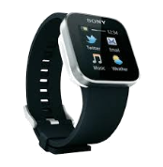
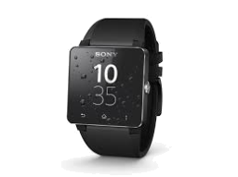
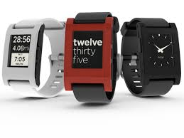

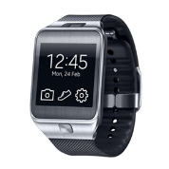
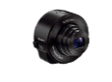
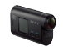
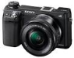
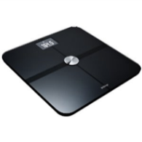
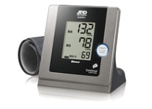
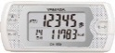
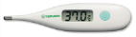
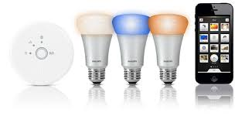



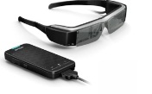


GotAPI：Provides a total framework for applications to access external devices through device APIs using Web technologies
Plug-Ins：Implement device APIs exposing services from external devices to applications through GotAPI
Cameras
Healthcare devices
Smart Light
Toys
Glasses
Remote Controls
Sensors
Web
Apps
Browser
Smartphone
GotAPI
Plug-Ins
Device API

GotAPIs

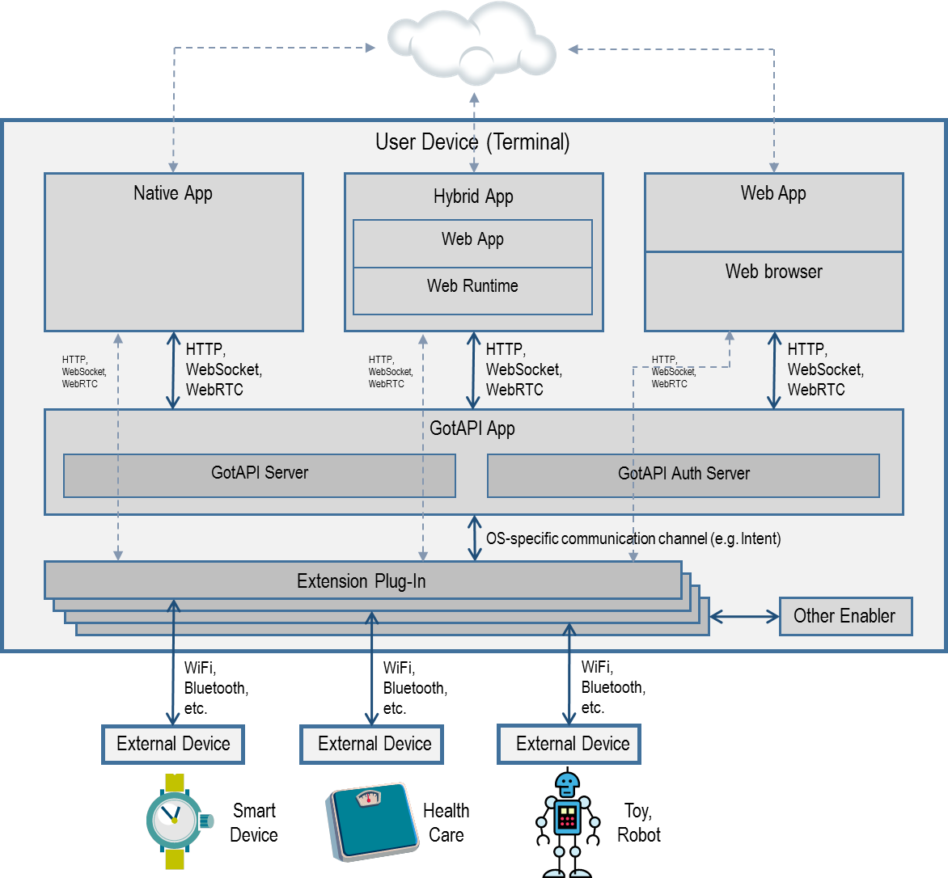

Example of RVI and OMA Devices APIs
The RVI will have two roles with respect to GotAPI server. These are: Plug-in and App Client. We think these two roles will support both 3rd party Web Applications in the car that have access to external devices and car data through its internal device APIs. In the second role, RVI as defined will support external devices by interacting with GotAPI server (Device API).
From implementation point of view, if you support one, you can support the second.
In use Case A, we are leveraging the existing work done in OMA (GotAPI V1.1 and DWAPI*) that is championed by NTT DoCoMo, KDDI, etc.

Use case A
Any 3rd party Web developers can access the RVI data and external device data through GotAPI/Device API. Ex: Auto Driving Lessons Coach.
3rd party App in this use case does not need to implement RVI.

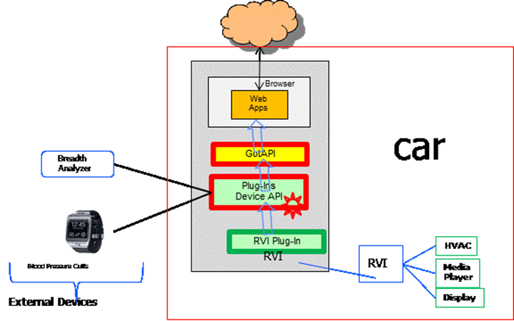
RVI is a plug-in
Use case A

Use case B
External devices supplying data to RVI. Ex: RVI exposing access to home lighting system.


RVI as Client/App
GotAPI
Device APIs
Device APIs
Watch
External Devices
Car
Use case B

- Change History (Informative)
<< The following is a model of a revision table. DELETE THIS COMMENT >>
Document Identifier | Date | Sections | Description
OMA-WP-xxyyz-200x0521-D | 21 May 200x | all | initial version of WP as permanent doc
OMA-WP-xxyyz-200x0630-D | 30 Jun 200x | 6.8 | Update to include agreed input to committee:  OMA-XY-200x-0053-CR_SpellingCorrections  OMA-XY-200x-0098-CR_AddSectionOnPeanutButter
OMA-WP-xxyyz-200x0812-D | 12 Aug 200x | n/a | Update to include agreed input to committee:  OMA-XY-200x-0101R2-CR_ImproveJellyReferences
OMA-WP-xxyyz-200x0818-D | 18 Aug 200x | 4.2, 6.3 | Update to include agreed input to committee:  OMA-XY-200y-0108R1-CR_ReminderTwoSlicesBread
OMA-WP-xxyyz-200x0924-A | 24 Sep 200x | 4.2, 6.6 | Approved by OMA TP  OMA-TP-200x-0172-INP_WP_xxyyz_ForApproval
- <Additional Information>
If needed, add annex to provide additional information to support the document.
Note that the styles for the headers in the appendix (App1, App2, App3) are different than the main body. The use below is intended to validate the styles to be used. Remove if not needed.
DELETE THIS COMMENT
  - App Headers
<More text>
    - More Headers
<More text>
      - Even More Headers
<More text>

